Black History Program
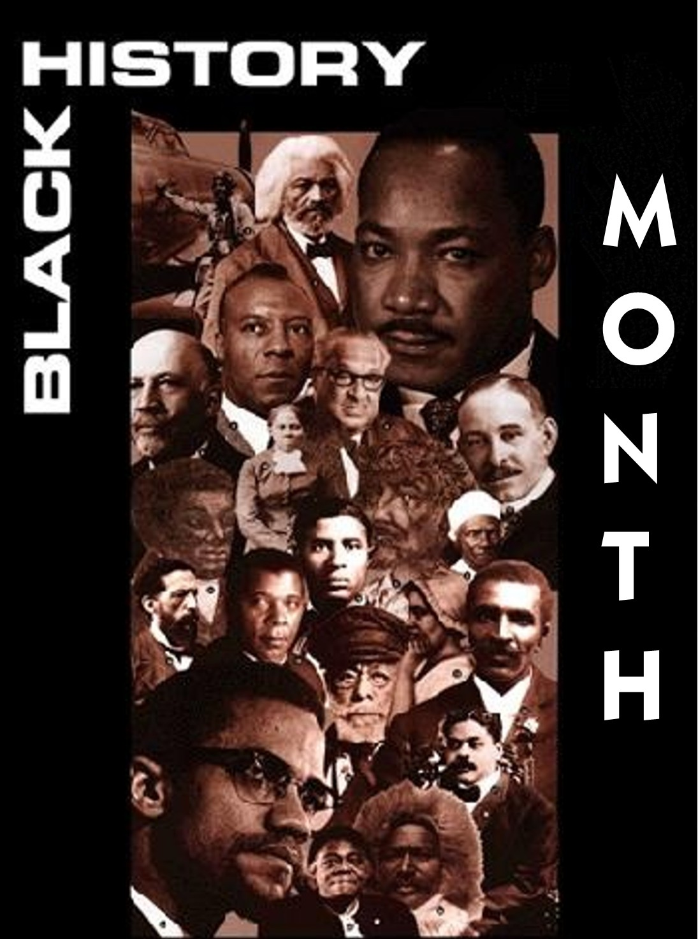 |  | Come join us as we celebrate our Heritage  We plan on having a great time! Our choir which is led by Rickie Vermont-Howell will be holding a tribute to Gospel legend Andre Crouch. There will be lots of fun praising our Lord… Glory be to God! Afterwards dinner will be served in the fellowship hall. There will be chicken, black eyed peas, greens, corn bread and desert. So come on out and join us as we celebrate Black History Month at Calvary!
February 22, 2015 4:00pm @ Calvary United Methodist Church
Calvary United Methodist Church
5268 W. Adams Blvd., Los Angeles, CA 90016
323.939.2037 | Rev. Helena Titus, Pastor www.facebook.com/CalvaryUnitedMethodistChurchLosAngeles

