Shoebox Ministry Shopping List

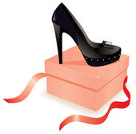

***All these items can be purchased at the 99 Cents Store***

Body Wash Q-Tips

Lotion Kleenex

Deodorant Breath Mints

Toothbrush & holder Dental Floss

Toothpaste Hair Comb

Hand Sanitizer Hair Brush

Sun Block Shampoo

First Aid Kit Conditioner

Anti-bacterial cream Nail Care Kit

Wet Wipes Assorted snacks

Petroleum Jelly Packaged Fruit Juices

Alcohol Pads Water

Hydrocortisone Cream Packaged Fruit

Women’s Hygiene Products Miscellaneous

Socks Zip Lock bags

Shoebox Ministry Shopping List

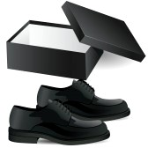

***All these items can be purchased at the 99 Cents Store***

Body Wash Q-Tips

Lotion Kleenex

Deodorant Breath Mints

Toothbrush Dental Floss

Toothpaste Hair Comb

Hand Sanitizer Hair Brush

Sun Block Shampoo

First Aid Kit Conditioner

Anti-bacterial cream Nail Care Kit

Wet Wipes Assorted snacks

Petroleum Jelly Packaged Fruit Juices

Alcohol Pads Water

Hydrocortisone Cream Packaged Fruit

Men’s Hygiene Products Miscellaneous

Socks Zip Lock Bags